DigI-VET

Fostering Digitization and Industry 4.0 in vocational education

2018-1-DE02-KA202-005145
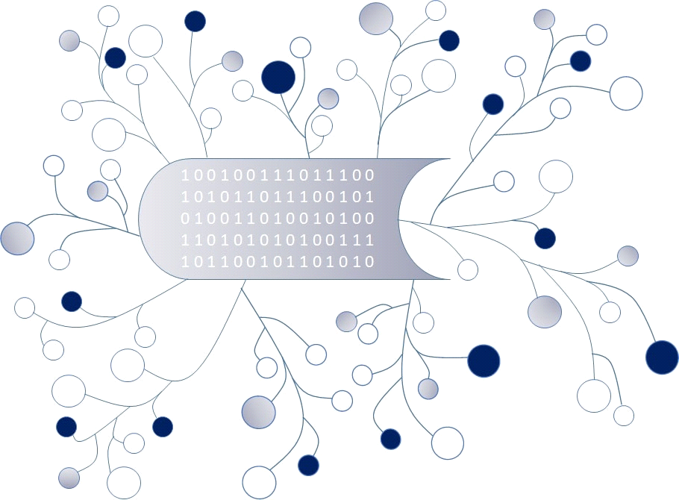

IO4 – Classroom didactical materials for Learners

Module A – Digitisation. Terms and Hystory

Autor: A.O.A. Arges

CONTENT:
- The difference between Digitisation, Digitalization and Digital Transformation
1.1. Terms and explanations .............……………………… ……………………………………… 3
1.2. Terms explanation using examples ……………………………………………….…………….5
1.3. Task – Video and questions………………………………………………………………………….7

2. The history of Digitisation and Digital Transformation
2.1. Short history and Terms ………………………………………………………………………. …….8
2.2. Task – Video and questions………………………………………………………………………….11

Referencies ………………………………………………………………………… ………………………..…………….13

1. The difference between Digitisation, Digitalization and Digital Transformation
1.1. Terms.
Digitisation is the transition (conversion) from analog representation (magnetic tape recordings, paper documents or any other medium) to digital, of things, in order to digitise and to automatize the processes or workflows.
By digitising we create a digital version (bits and bytes, bytes) of analog, physical things, such as: paper documents; microfilm images; classic photos; sounds and animations; medical records, location and time data; ID cards; books, brochures, magazines, paintings, sculptures, architectural works, etc.
From the perspective of the relationship with the original document, digitisation is:
1. Duplication of the original document (scanning of a rare book which is made available to researchers), in digital format, and the original remains at the place of storage;
2. The disappearance of the original (capturing a conversation at a presentation or event), the digital format continuing to exist;
3. Digital representation of a building through the original design or by scanning the physical image.
From the perspective of the purpose of digitisation:
1. Transfer of physical information in digital format.
We use scanners and make a digital representation (document image, jpg, gif, etc.) to later use recognition software (integrated technologies) and data extraction to power the workflow, systems, processes, DBMS, to achieves various objectives: recognizing the person by a photograph, recognizing the person by walking or iris shape, DNA code, fingerprint, etc);
2. For action, processes.
We digitise to enter data into a chain of events, actions, workflows or processes. From this perspective, digitization is the connection of people, processes, data and things to provide relevant and intelligent information to various processes.

Digitalisation is defined from three distinct perspectives:
1. In business, digitalisation is the activation, improvement, transformation of business operations or functions, models, processes or activities, through the use of digital technologies and data, actionable towards a predetermined goal.
Digitalisation refers in particular to recording, storage and management systems, to systems of involvement and knowledge through the use of digitised data and processes.
2. The second perspective is the digitalisation of an environment, areas or flow. The digital workplace involves: digital things; digital tools; social collaboration platforms; unified communication platforms.
3. The third perspective of digitalisation refers to the continuous adoption of digital technologies in all societal and human activities: digital healthcare, predictive or preventive medicine; digital governance and marketing; digital advertising.
In conclusion, digitalisation aims to change both operations and business models, as well as changing revenue streams and new business opportunities.

Digital transformation is the profound and accelerated transformation of activities, processes, skills and business models, in line with the opportunities of digital technologies and their impact on cognitive-emotional activity, behavior and actions of individuals leading society to achieve a new economy and society.
In relation to the impact they have and the implementation chronology we have: digitisation, digitalisation and digital transformation.

1.2. Terms explanation using examples
Some of the most common words used lately are digitization, digitalization and digital transformation. However, there is confusion about these terms and a debate needs to be made on the distinction between them, the differences being significant.
Here is a presentation using the latest generally accepted declination from the point of view of service providers.
Digitisation: the transition from analog to digital formats
This is where it all begins.
Years ago, and often even today (in many fields), business processes were analogous. To better understand we will use a common example: if you have a problem with a device, call the service and explain the problem and then an operator fille out an order form. A service technician has the task of carrying out a field visit to evaluate your problem with the device and, (optimistically), fixes the problem. All customer files, product manuals, repair manuals are at some point available on paper. This meant that the service technician could have arrived on the scene with a file (which could have contained more information, from the customer's name and address to the product history and a list of spare parts).
Digitisation is the process of collecting all available and then accessible information in a digital format.
Digitalization: the use of digitised information in your work
Once the analog information has been digitised, it can be integrated and then used in various software applications with good premises for automation. We can continue with the example above: centralized customer data, including contact information and product history, helps service technicians be informed of their customers' past problems and the types of problems they may encounter. This means that they come already prepared for an intervention with a set of structured knowledge that helps them effectively in the service process. In addition, information collected from different service technicians about the same or similar products can be used to create checklists to resolve recurring issues. This type of knowledge exchange can be extended to product manuals and video tutorials available on any mobile device. All these types of tools provide technicians with access to as much information as possible to help them make a quality repair right on the first visit.
Digital transformation: creating completely new business concepts taking advantage of digitalization
Due to digitisation and digitalisation, the datas are easily accessible for use on various platforms, devices, interfaces. Digital transformation is the process of developing new business applications that integrate all this digitised data and digitalised applications. Let's take a look at a new popular example today: Netflix. In the past, the company launched by renting movies on various media (cassettes, DVDs) delivered by mail. Once the movies were digitized, a whole new business model emerged: video streaming.
Digitalisation leads to digital business, digital transformation requires digital business and digitisation.

CONCLUSION:
Digitisation: Only the transformation from analog to digital.
Digitalisation: Make digital information work for you.
Digital Transformation: Using the benefits of digitalisation to create new business.

1.3. Tasks. Please answer the following questions
I. Which one of the following statements are correct? (multiple choices):
Digitisation means:
a) conversion of data from traditional forms of storage into binary code.
b) creation of unified communication platforms
c) transformation of business models, in accordance with the opportunities of digital technologies.
d) the transition of things from analog to digital representation.
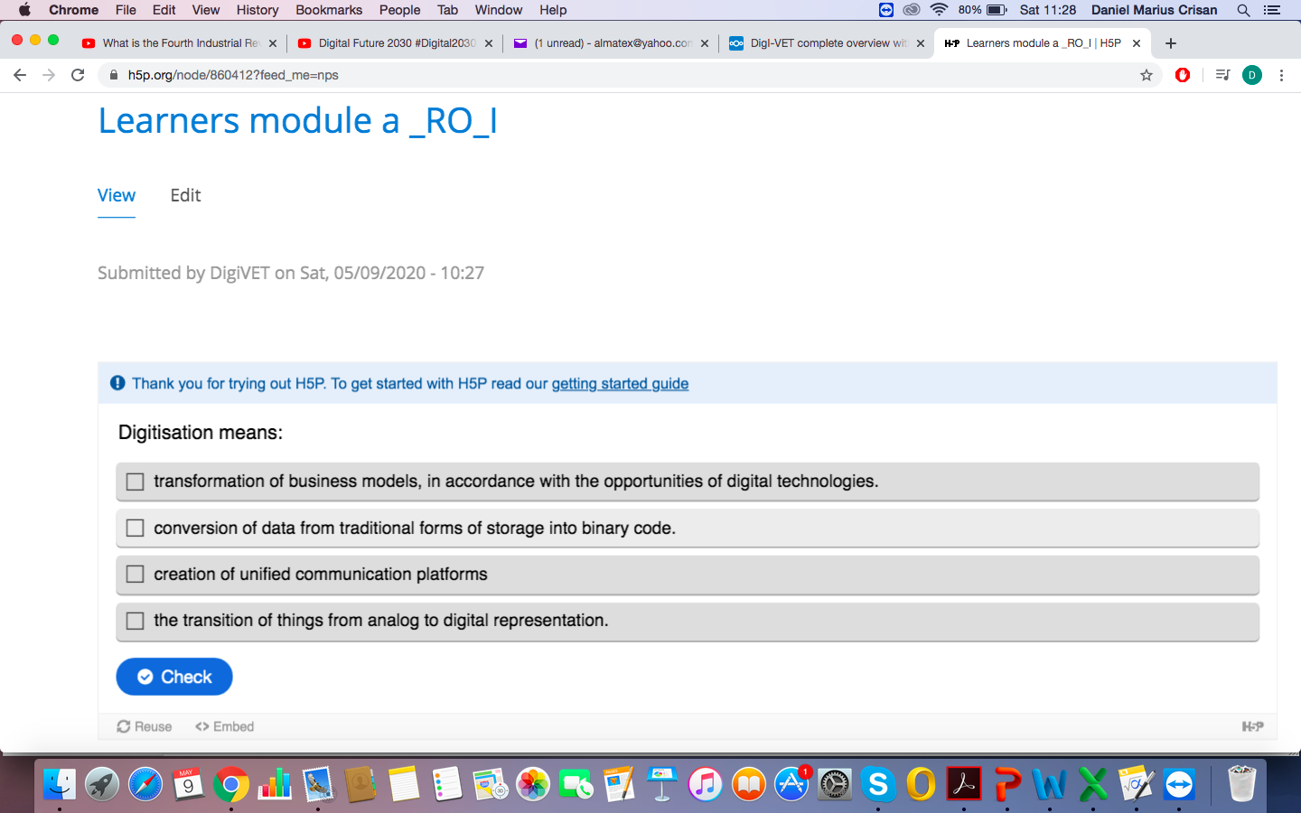

II. Which of the following definitions are correct? (multiple choices):
a) Digital transformation consists in using the advantages of digitalization to create new businesses.
b) Digitization means only the transformation from analog to digital.
c) Digitization means making digital information work for you.
d) Digital transformation means the use of new technologies (virtual reality, drones, robots, etc.) to increase labor productivity and human safety.
e) digitalization refers to the continuous adoption of digital technologies in all social and human activities.
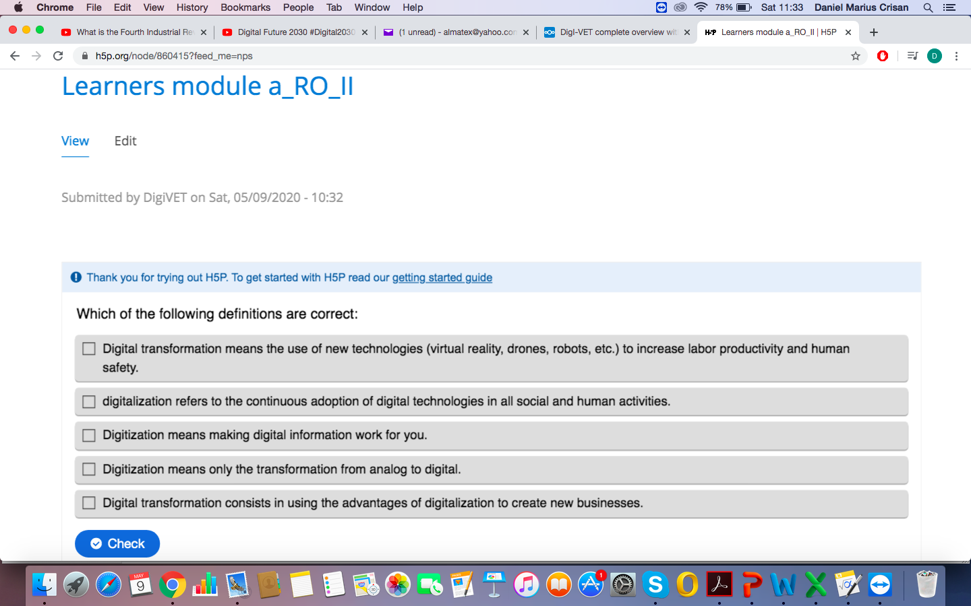
2. The history of Digitisation and Digital Transformation
2.1 Short history and Terms

Here are a few milestones in the story of the adoption and proliferation of today’s most widely spoken language
Here are a few milestones in the story of the adoption and proliferation of today’s most widely spoken language.
1679 Gottfried Wilhelm Leibniz develops the modern binary number system and, in 1703, publishesExplication de l'Arithmétique Binaire (Explanation of Binary Arithmetic), linking it to ancient China.
1755 Samuel Johnson publishes A Dictionary of the English Language and includes an entry for “Binary arithmetick,” quoting Ephraim Chambers’ Cyclopaedia: “A method of computation proposed by Mr. Leibnitz, in which, in lieu of the ten figures in the common arithmetick, and the progression from ten to ten, he has only two figures, and uses the simple progression from two to two. This method appears to be the same with that used by the Chinese four thousand years ago.”
1847 George Boole introduces Boolean algebra in The Mathematical Analysis of Logic, creating the field of mathematical logic, leading eventually to universal computation. In 1854, he writes in An Investigation into the Laws of Thought: “The respective interpretation of the symbols 0 and 1 in the system of logic are Nothing and Universe.”
June 25, 1945 John von Neumann’s A First Draft of a Report on the EDVAC is distributed to 24 people working on the development of the EDVAC, one of the earliest computers. It documents the key decisions made in the design of the EDVAC, among them the decision to use binary to represent numbers, thus reducing the number of components required compared to its predecessor, the ENIAC, which used the decimal system. The document became the technological basis for all modern computers.
1948 Claude Shannon publishes "A Mathematical Theory of Communication" in the July and October issues of the Bell System Technical Journal. Shannon: “If the base 2 is used [for measuring information] the resulting units may be called binary digits, or more briefly bits, a word suggested by J. W. Tukey. A device with two stable positions, such as a relay or a flip-flop circuit, can store one bit of information.”
1954 General Electric’s Major Appliance Division plant in Louisville, Kentucky, installs the UNIVAC Icomputer, the first business use—payroll processing and manufacturing control programs—of a computer in the United States. “The Univac I was also hooked up with speakers, and the operator had the machine playing classical music each evening,”recalls Burton Grad who designed and wrote (in machine language) a manufacturing control program for GE’s Dishwasher and Disposer Department.
1955 John Hancock Mutual Life Insurance Co., a pioneer in digitizing customer information, digitizes 600 megabytes of two million life-insurance policies.
1962 The term database is mentioned in print for the first time, according to the Oxford English Dictionary, quoting a Systems Development Corporationtechnical memo: “A ‘data base’ is a collection of entries containing item information that can vary in its storage media and in the characteristics of its entries and items.”
1969 Willard Boyle and George E. Smith at AT&T Bell Labs invent the charge-coupled device (CCD), transforming light into electric signals. The CCD has played a major role in the development of digital imaging in general and the development of digital cameras and medical imaging in particular. Boyle and Smith were awarded the 2009 Nobel Prize in Physics.
1979 Federal Express launches COSMOS(Customers, Operations, and Services Master Online System), digitizing the management of people, packages, vehicles, and weather scenarios in real time, with a computer storage capacity of 80 gigabytes.
August 17, 1982 The first commercial compact disc(CD) is produced, a 1979 recording of Claudio Arrau performing Chopin waltzes.
June 1990 General Instruments, an American manufacturer of cable television converters and satellite communications equipment, upsets the race to build the television of the future by announcing it has succeeded in squeezing a digital HDTV signal into a conventional broadcast channel. Up until then all the companies preparing proposals for an HDTV standard were working on analog systems.
1991 The first 2G cellular network is launched in Finland. 2G networks used digital signals rather than analog transmission between mobile phones and cellular towers, increasing system capacity and introducing data services such as text messaging.
May 1993 O’Reilly Digital Media group launches the Global Network Navigator (GNN), the first commercial web publication and the first website to offer clickable advertisements.
1995 After a five-year pilot project, theNational Digital Library program begins digitizing selected collections of Library of Congress archival materials.
1996 E-gold is launched, becoming the first successful digital currency system to gain a widespread user base and merchant adoption.
2002 Digital information storage surpassesnon-digital for the first time.
2003 Electronic payments in the U.S. surpass the use of cash and checks for the first time.
2007 94% of the world’s information storage capacity is digital, a complete reversal from 1986, when 99.2% of all storage capacity was analog.
March 2007 Estonia becomes the world’s first country to use internet voting in a parliamentary election.
October 2008 Satoshi Nakamoto publishes "Bitcoin: A Peer-to-Peer Electronic Cash System," describing the first decentralized digital currency. In October 2015, The Economist stated that blockchain, the technology behind bitcoin, “could transform how the economy works.”

2.2. Tasks:

I. Watch the video concerning the history of digitalisation and digital transformation. https://www.youtube.com/watch?v=iOdG4Atc2sY
Please write down the essentials and then answer the following questions (multiple choices):

Wich of the folowing statements are corect?

a) as a result of digitization, the information storage capacity has grown 4 times faster than the world economy
b) in 2011 the number of readers who informed themselves online exceeded that of those who read the newspapers in order to be informed.
c) in the future people will no longer have jobs, they will be replaced by robots
d) nowadays, at any moment over 23 million are connected online who talk to each other.

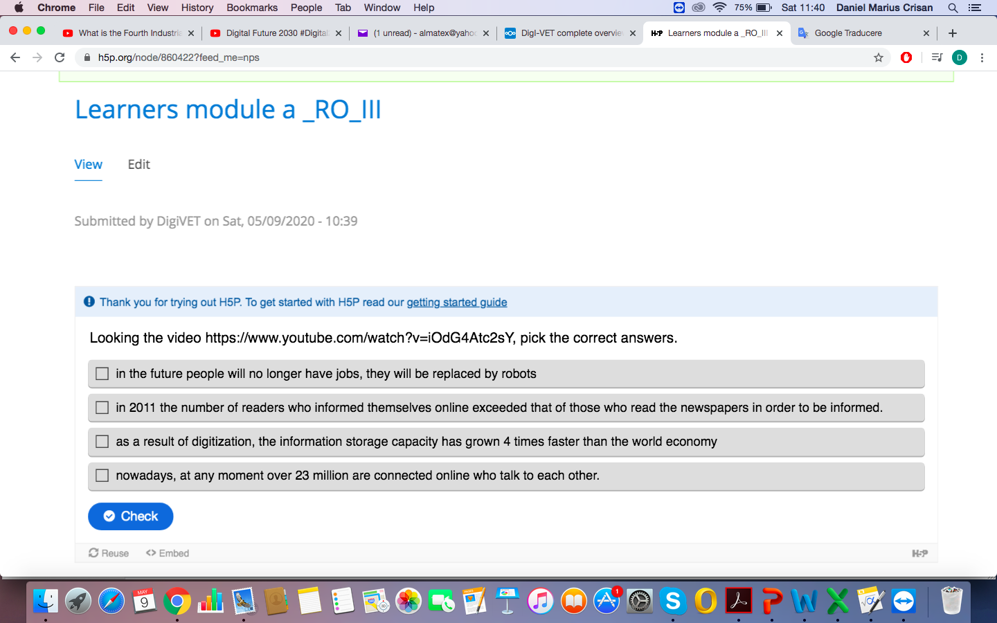

II. Watch the video carefully, presenting some aspects of the digital transformation in Sweden.
https://dl-mail.ymail.com/ws/download/mailboxes/@.id==VjN-yg8Wn-tmEHPwMwDVids6ETwRId_7tmO5f6d8tdJVLiuw8d1DfQwatJjYTaZNo-VHBmBxuc2UTjmHlmQVvjcwMQ/messages/@.id==AIkibN94PsahXq57YArdQFW2UjQ/content/parts/@.id==2/raw?appid=YMailNodin&ymreqid=9b29e981-164d-7380-1c55-020000019800&token=zitEzqOML3j84e6ealFTT5U7-km5qEQF52lp7AcCuBac0ZENuxotU1td8JhDzjr31-3oFZzDwpUNsBbpYEwEHVpN9cVZpwKi1m5WgdmxenEaXYsR4RvwvgV3QYEmzl84

What are the thoughts that go through your mind seeing him?

III. Digital transformations can also have unpleasant consequences. Watch and comment on the next video:

Bibliografie

Aquilani, B.; Silvestri, C.; Ruggieri, A. Sustainability, TQM and value co-creation processes: The role of critical success factors.
Kliestik, T.; Misankova, M.; Valaskova, K.; Svabova, L. Bankruptcy Prevention: New Effort to Reflect on Legal and Social Changes. Sci. Eng. Ethics
Kliestikova, J.; Misankova, M.; Kliestik, T. Bankruptcy in Slovakia: International comparison of the creditor’s position. Oecon. Copernic. 2017, 8, 221–237
Eremin V.V. and Kharisova E.V. (2016). MSU boarding school for gifted children is a model of learning in a changing world. Natural science education: a look into the future. Collection. Мoscow: MSU Publishing, pp. 240 Internet and education. Do Russians use the Internet for educational purposes? FOMNibus, (30 July 2015).
https://www.khanacademy.org/ Overview and Analysis of Policy Models for the Integration and Innovative Use of Digital Technologies in Education. (n. d.). https://ec.europa.eu/jrc/en/digitaleducation-policies Pearce N., Weller M., Scanlon E. and Kinsley S. (2011). Digital scholarship considered: how new technologies could transform academic work.
Popova M. (2016). The Big Brake. RBC + Education,
Stuart, K. (2014). What every parent needs to know about video games: a crash course.

DIGITIZARE, DIGITALIZARE ȘI TRANSFORMARE DIGITALĂ VIOREL IULIAN TĂNASE, RUXANDRA VICTORIA PARASCHIV www.cercetari.institutuldefilosofie.ro

